Tutorial 1
Complete A Set of Training Videos on Tableau
Go to http://www.tableau.com/learn/training

Step 1: Click the “down arrow” next to “Connecting to Data”
Complete the videos that are marked below.

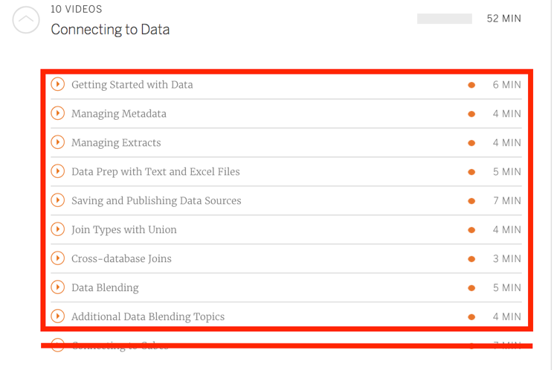
Step 2: Click the “down arrow” next to “Calculations”
Complete the videos that are marked below.

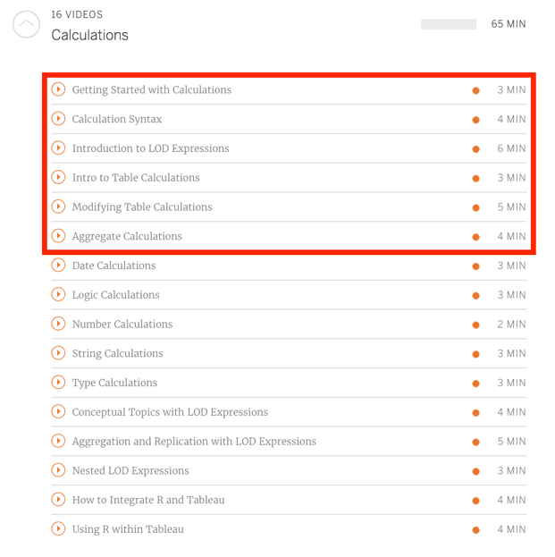

Step 3: Getting Data Ready for Tableau

View the following files on LMS :
NYCTrashWide.xlsx
NYCTrash.xlsx

Note the structure of the NYCTrash file, and how it is different from the wide file:

Wide:

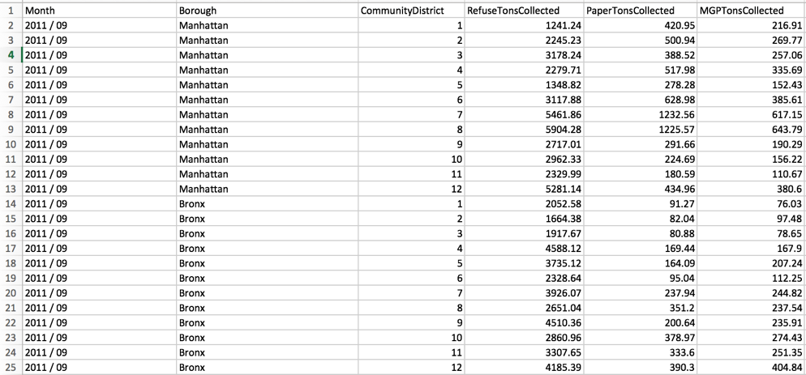

Vs. LONG format:

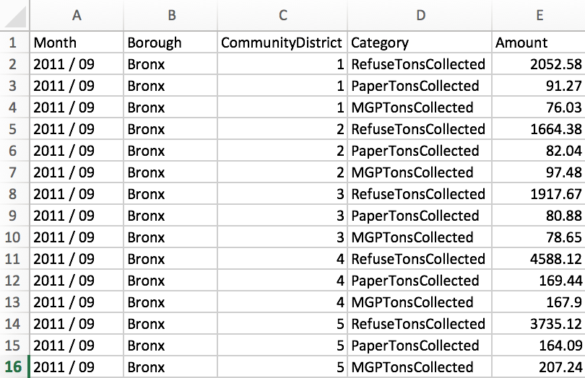

In the long data there are three rows for each row in the original data, and the fields for the different kinds of trash have been placed one on each row. If you are provided data in the wide format, you will need to switch to long using Tableau’s Pivot command.

Step 4: Build a visualization that shows rank order of total trash collected by borough. It should look something like this:

Using the NYCTrash.xlsx file (NOT WIDE)
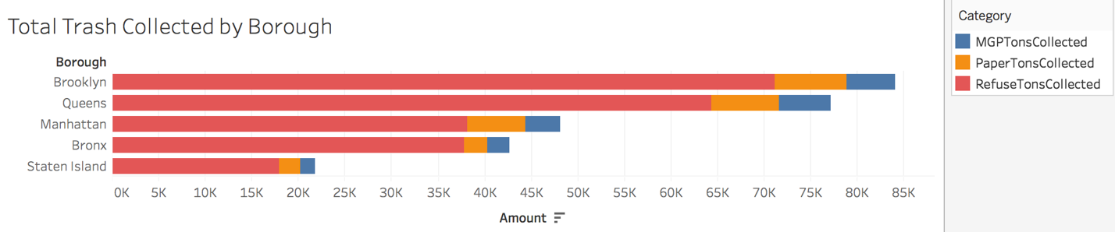

Step 5: Create a Calculated Field to create an “IsRecycling” Field

Create a new calculated field, and use the IF THEN ELSE function structure to create a field that contains the value 1 if the category is MGPTonsCollected or PaperTonsCollected, and 0 if the category is RefuseTonsCollected. You will need to ensure that your field is “discrete” and is a “dimension”.

Step 6: Create a new “Recycling vs. Refuse” chart.

Create a SECOND visualization (duplicate the first sheet) display green if the material collected is recycling, red if not. Your visualization should look like this. ( You will need to use the new dimension you created in Step 5)

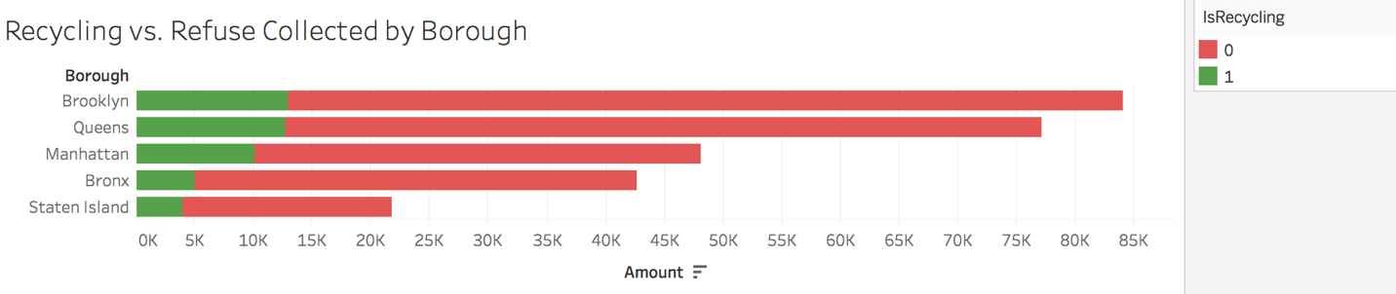

Step 7: Create a new calculated field that computes “Per Capita” refuse totals.

Download and add the NYCPopulation.xlsx file to your data (you learned about using multiple files in the videos in step 1). Ensure you join the tables correctly. If you would like more information about what the various types of JOINs mean, read through this: https://onlinehelp.tableau.com/current/pro/desktop/en-us/joining_tables.html.

Create a New Calculated field called “Per Capita Amount” that divides the amount collected by the population value. Then, duplicate the previous sheet, and add the new field as a new column. Your visualization should look like this:
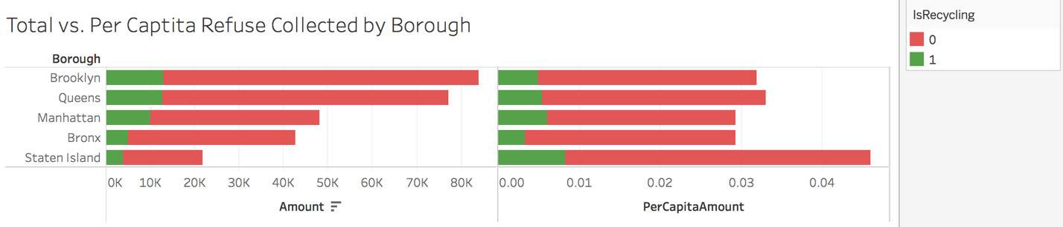

Step 8: Create a “Percent” Representation of the ratio of Recycled to Refuse Collected.

Create a New Sheet, and Create a Column Chart with a Column for each borough. Color by “IsRecycled” – Your Graph will look like the graph below on the left. Now, using a table calculation, display the data as a percent ratio. Your graph should change to look like the graph on the right below.

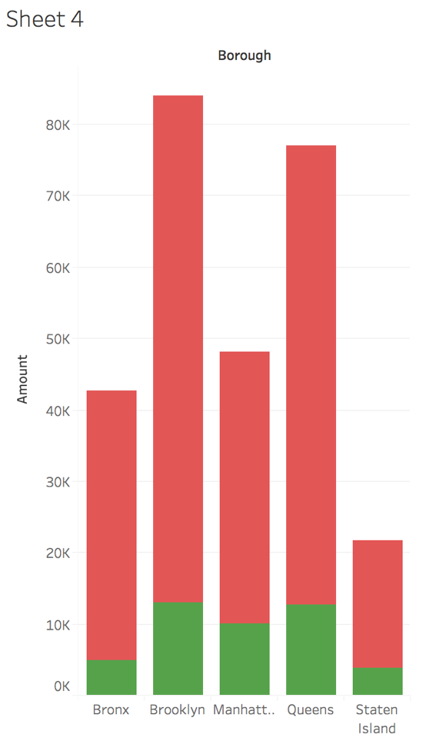 | 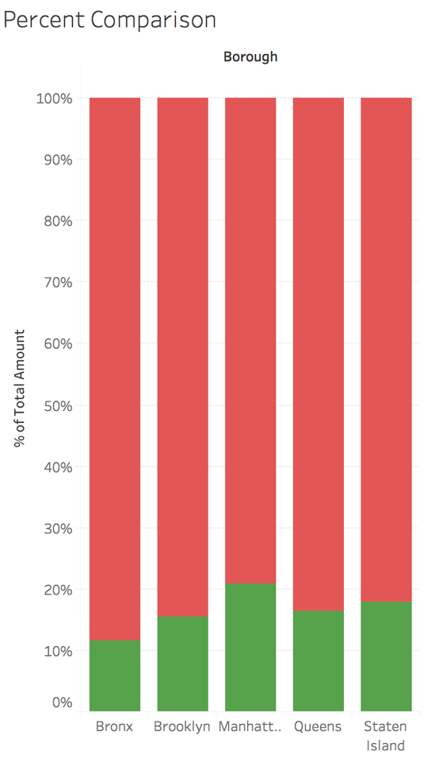

NOTE: To complete this step, you may need to google the use of Tableau “Percent of Total”, and “Compute using Cell”. In addition, we will expand this exercise a great deal when we learn about Level of Detail Expressions.

Step 9: Submit File

Submit your PACKAGED tableau workbook on LMS. You will lose 25% of the marks if the workbook is NOT packaged.

